**Outputs of** **CI/CD Deployment for Spring boot Application.**

**Step 1: Write spring boot program:**

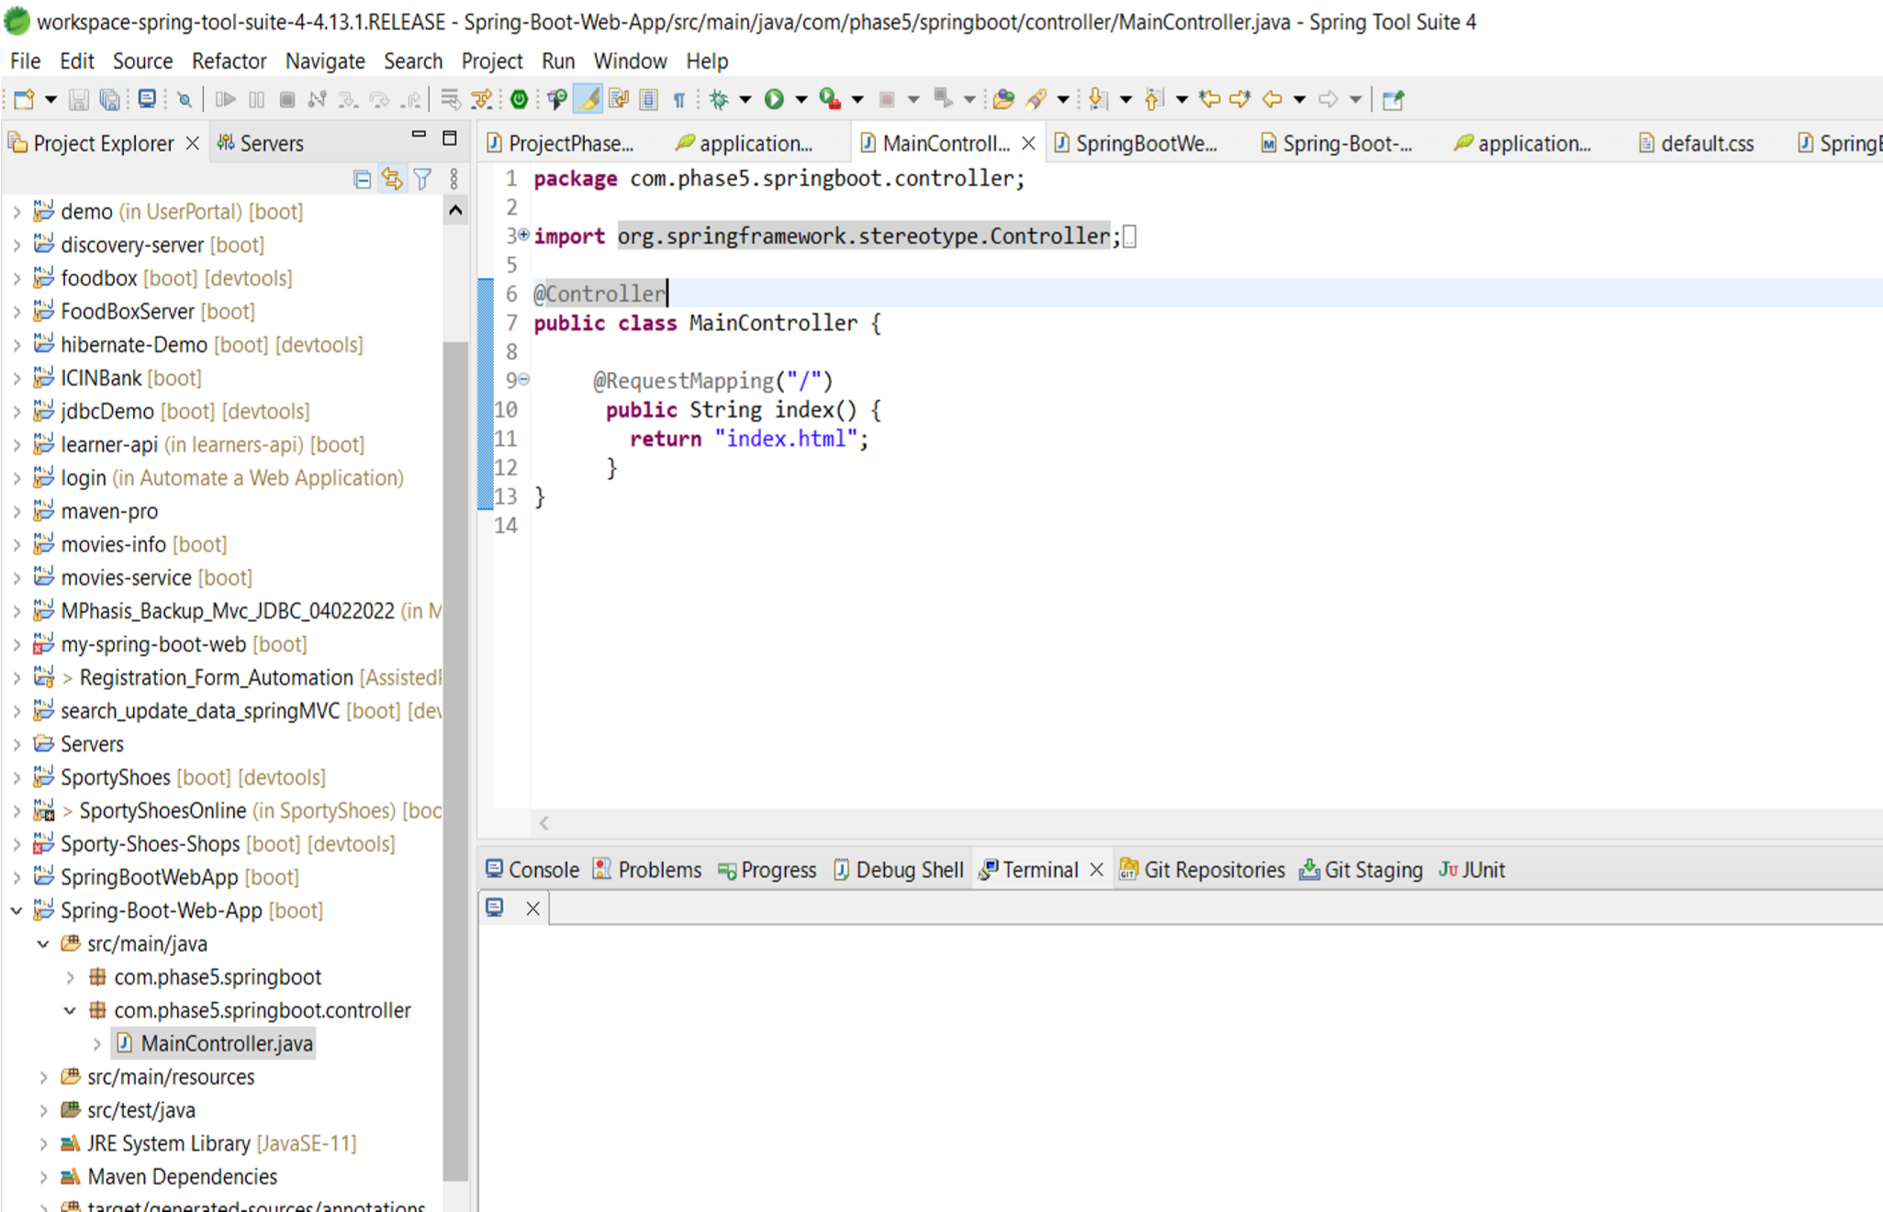

* **Step 2: Launching EC2 instance:**
  1. Click on launch instance to run any instance
  2. Select the AMI

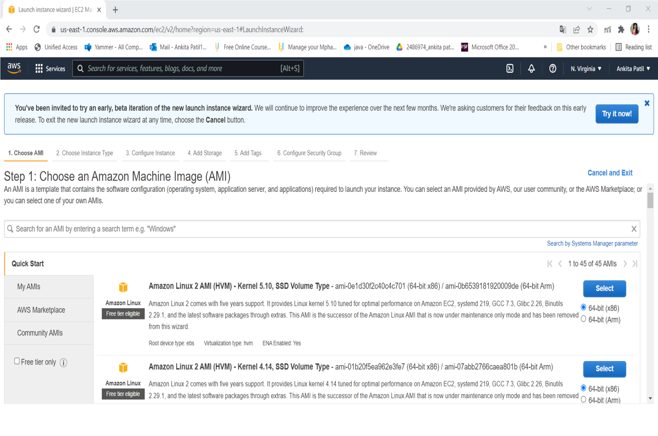

* 1. Select t2.micro as the instance type

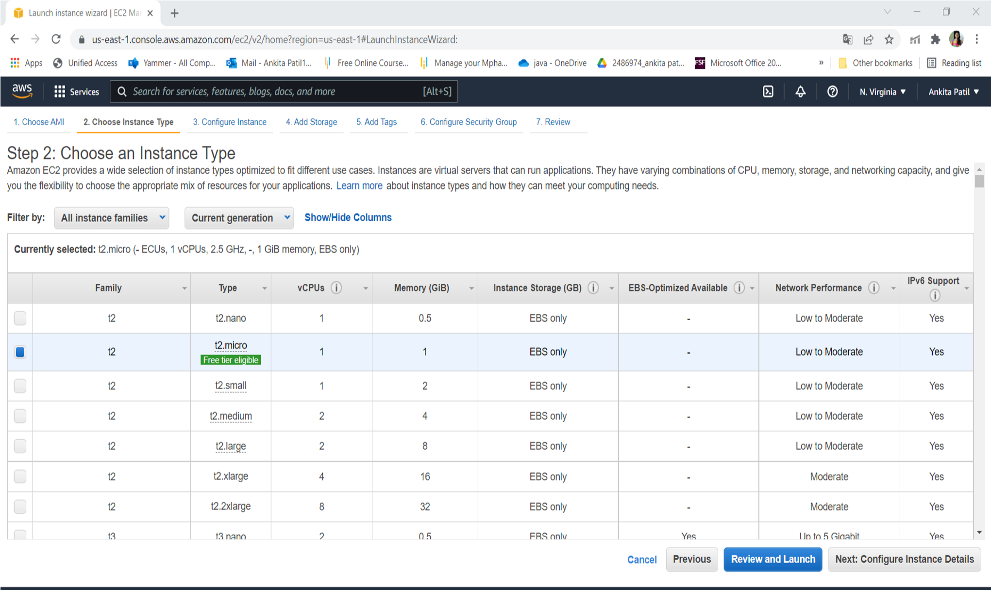

* 1. Specify the number of instances, networks, placement groups, and IAM roles and click Next

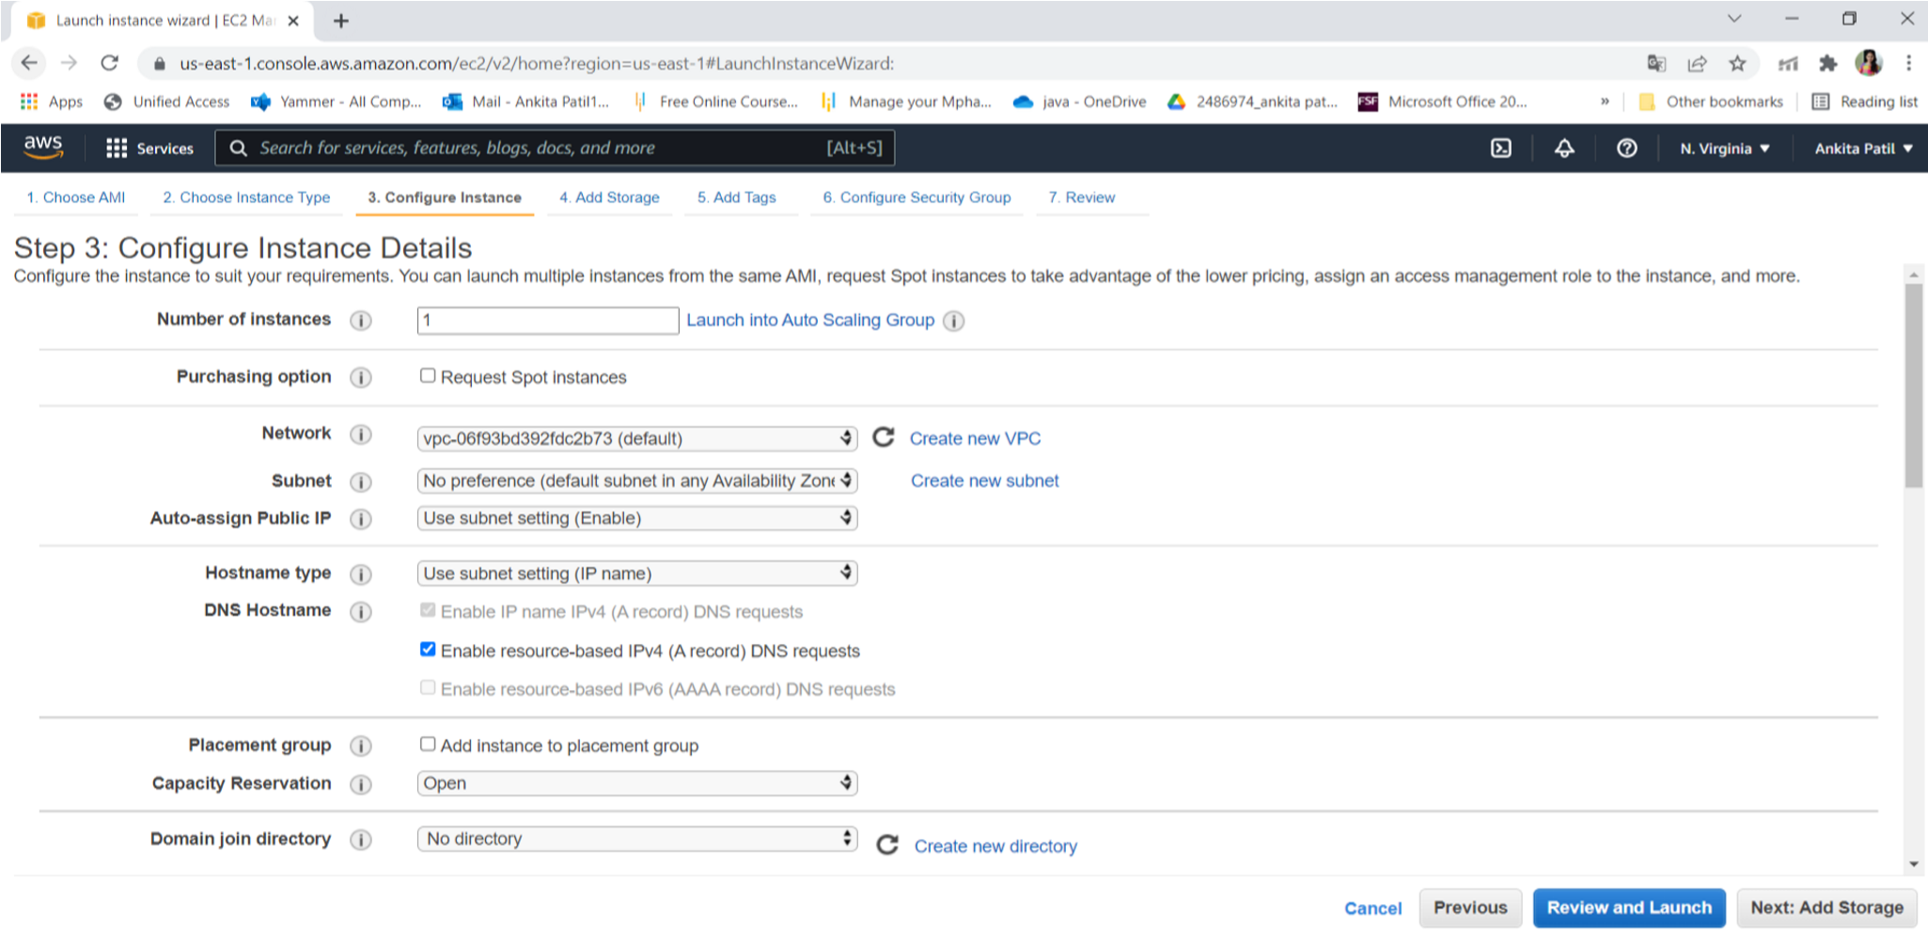

* 1. Add storage

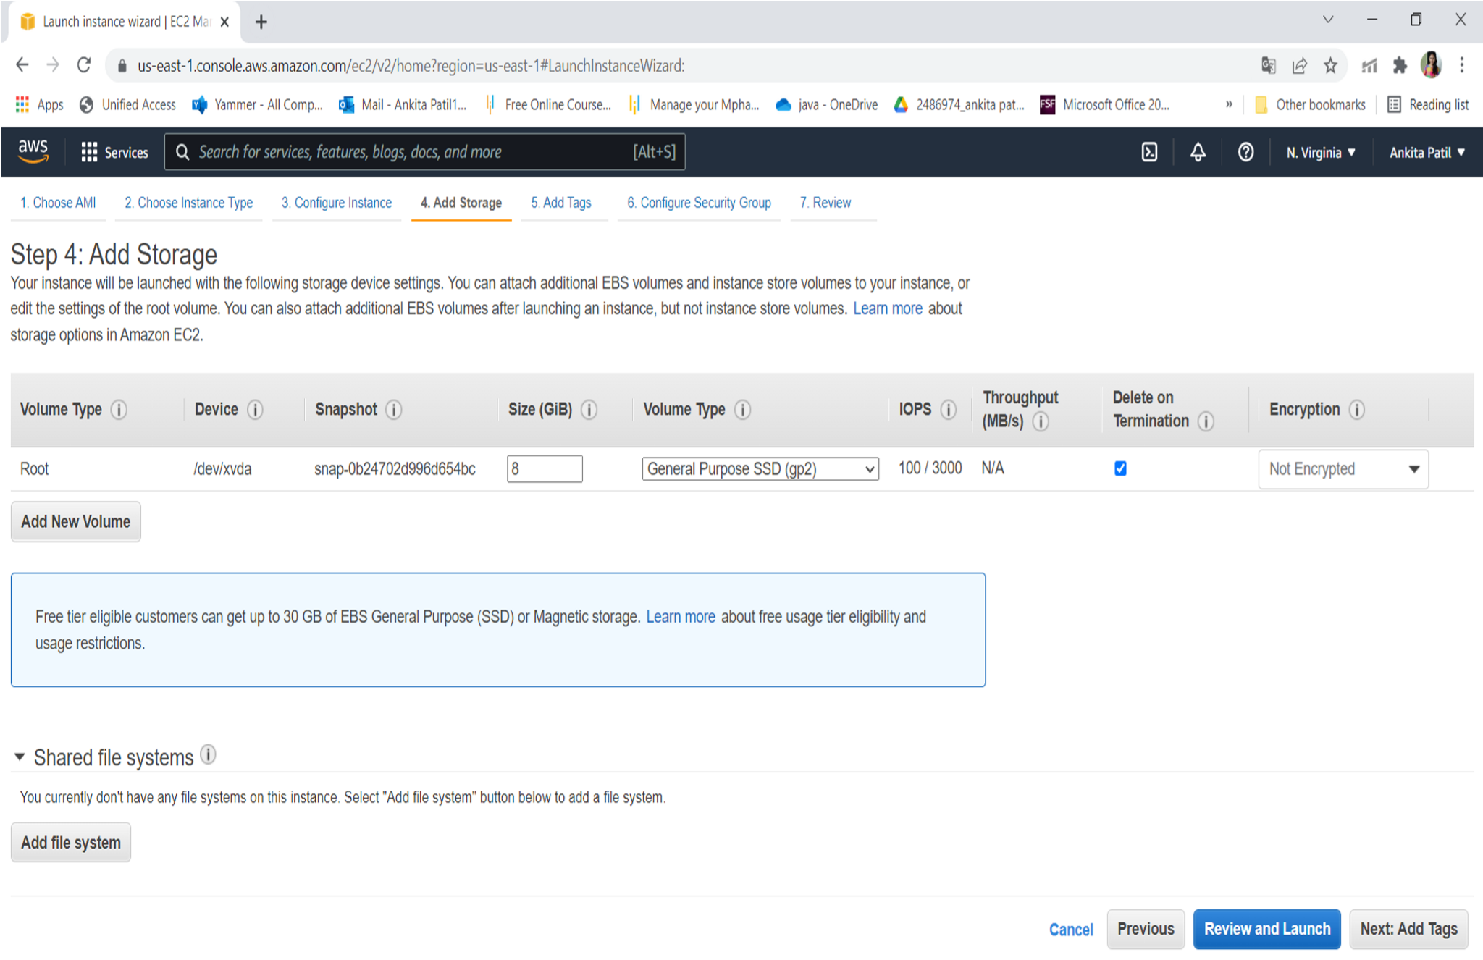

* 1. You can add a key-value pair to the instance

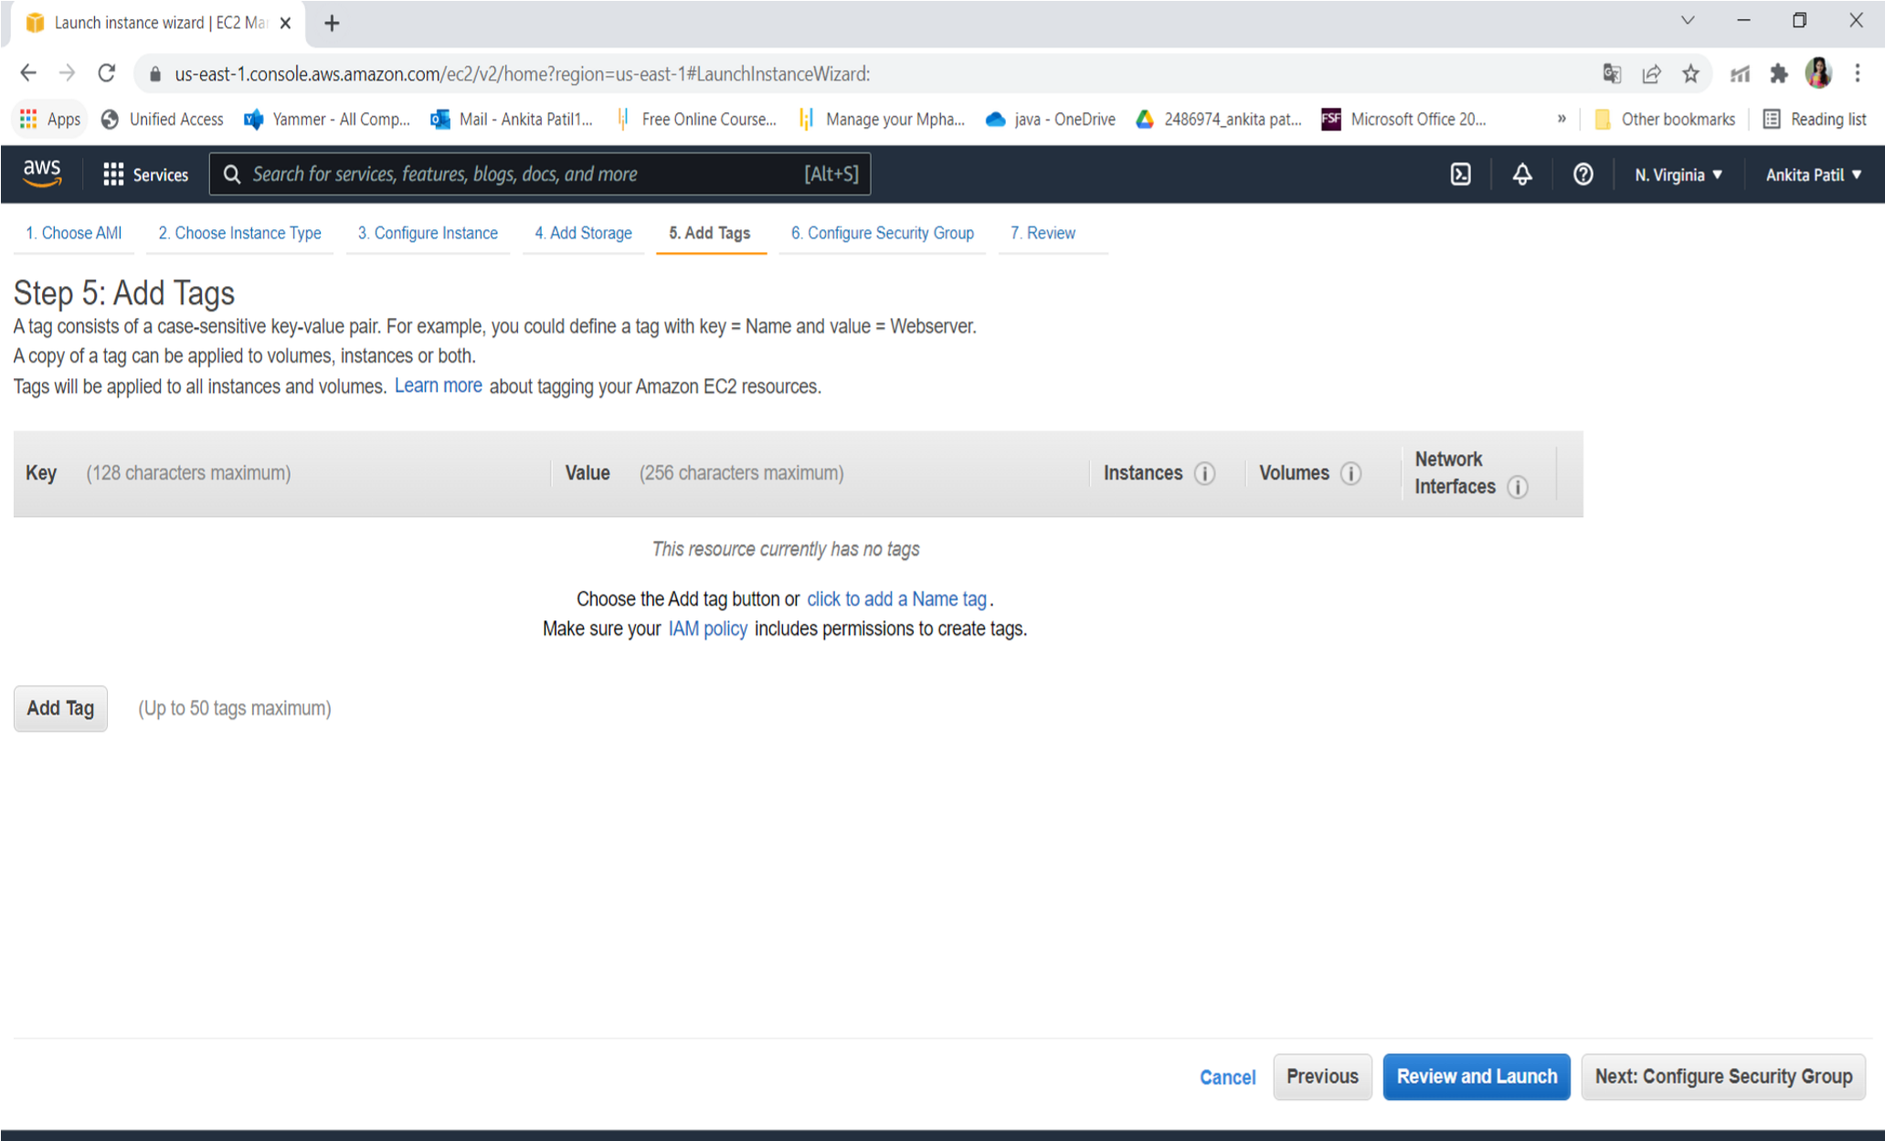

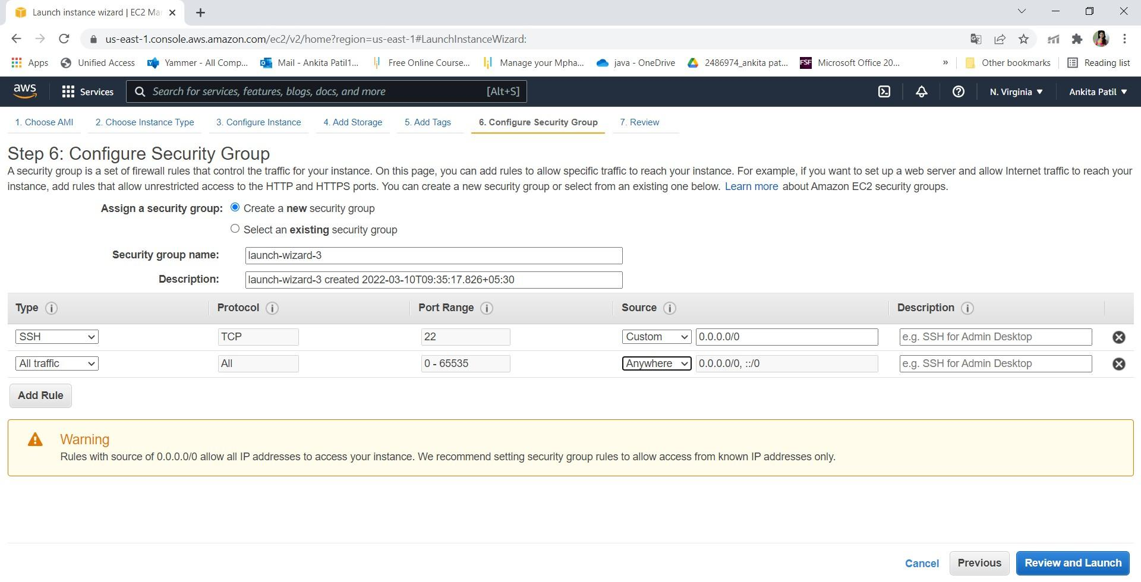

* 1. Click on launch

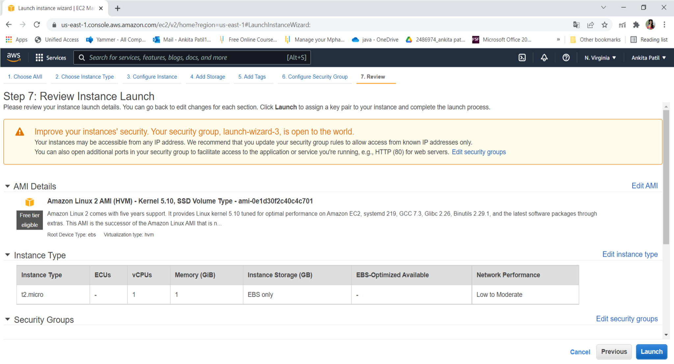

* 1. Create key pair

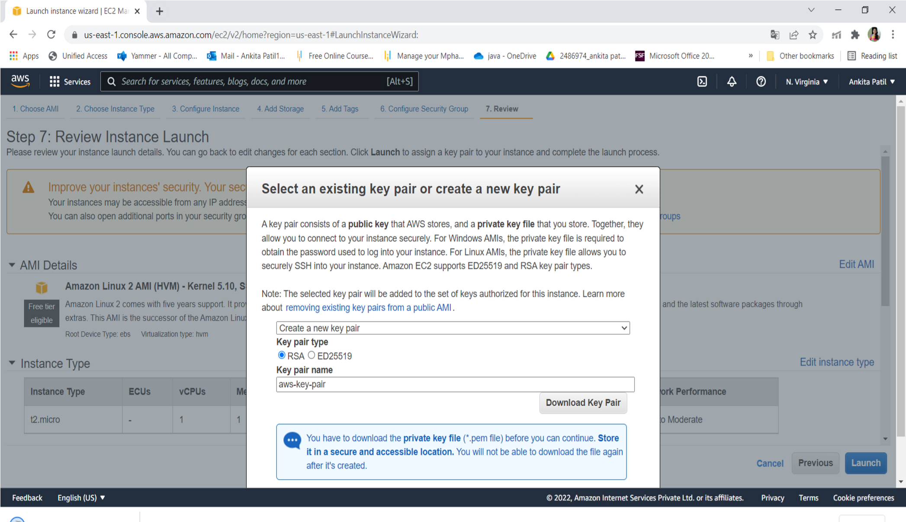

* 1. Click on view instance

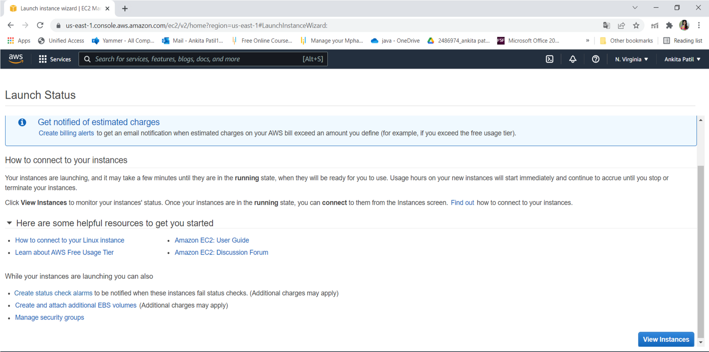

* 1. Connect the instance

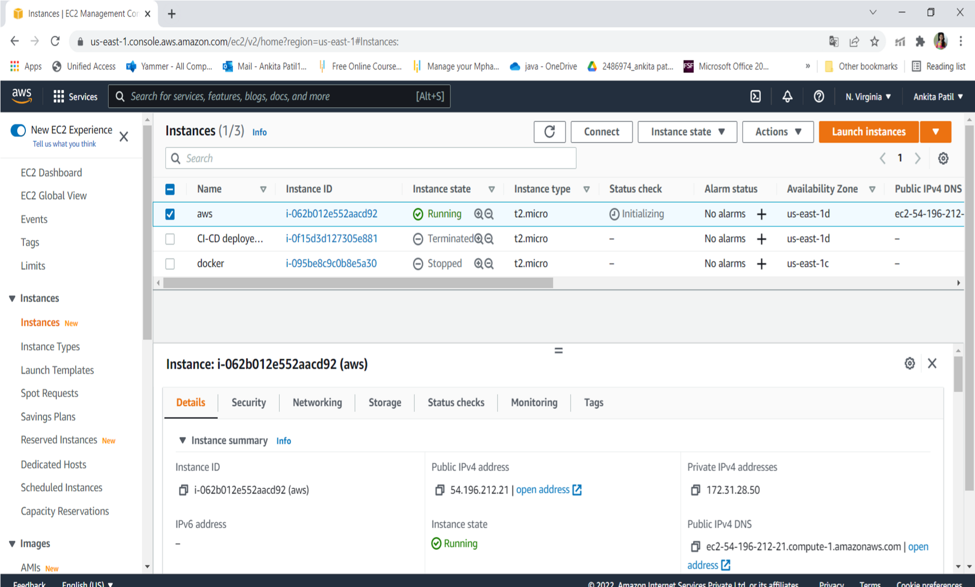

* **Step 3: Connect to EC2 instances:**

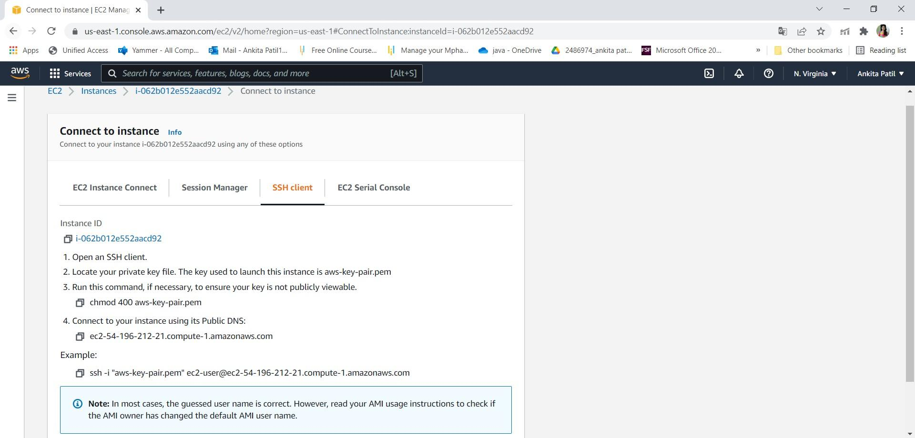

11. Click on Connect on EC2 dashboard & Run the ssh command provided

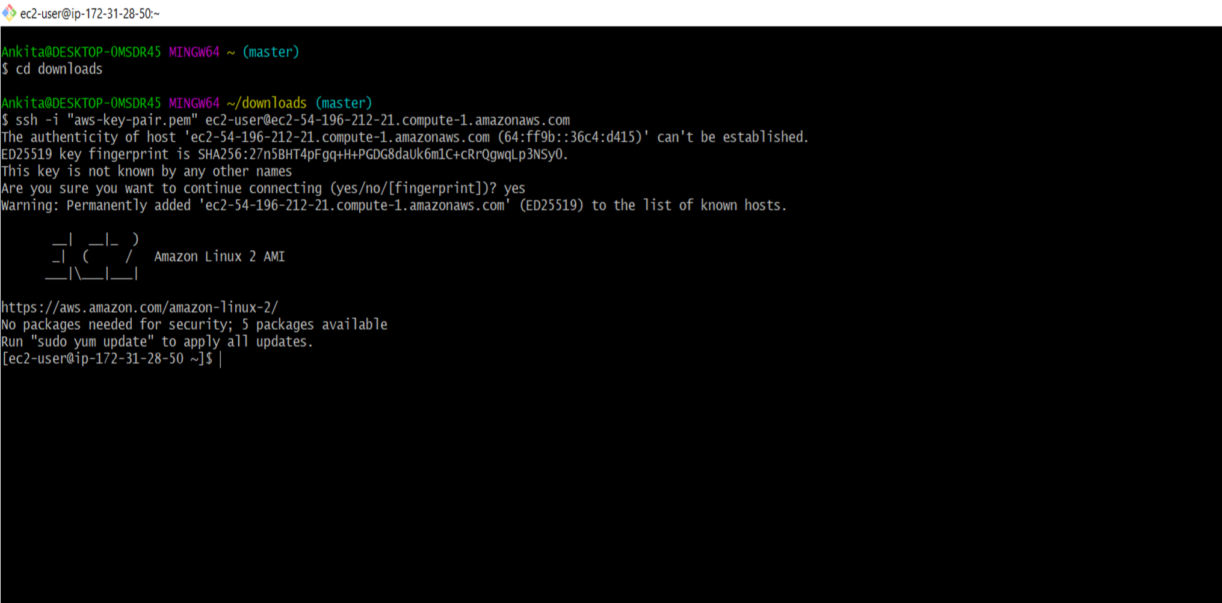

**Step 4: Creating S3 Bucket:**

1. Create Bucket to store jar file:

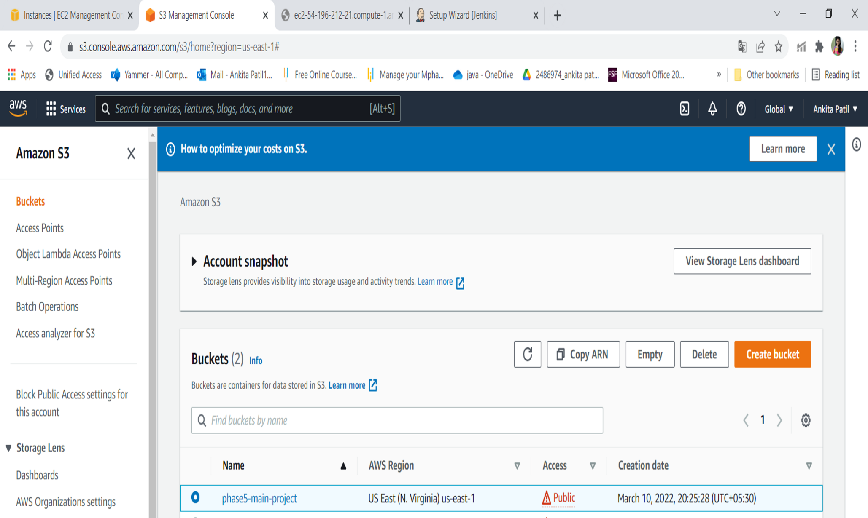

Step 5:Adding jar file:

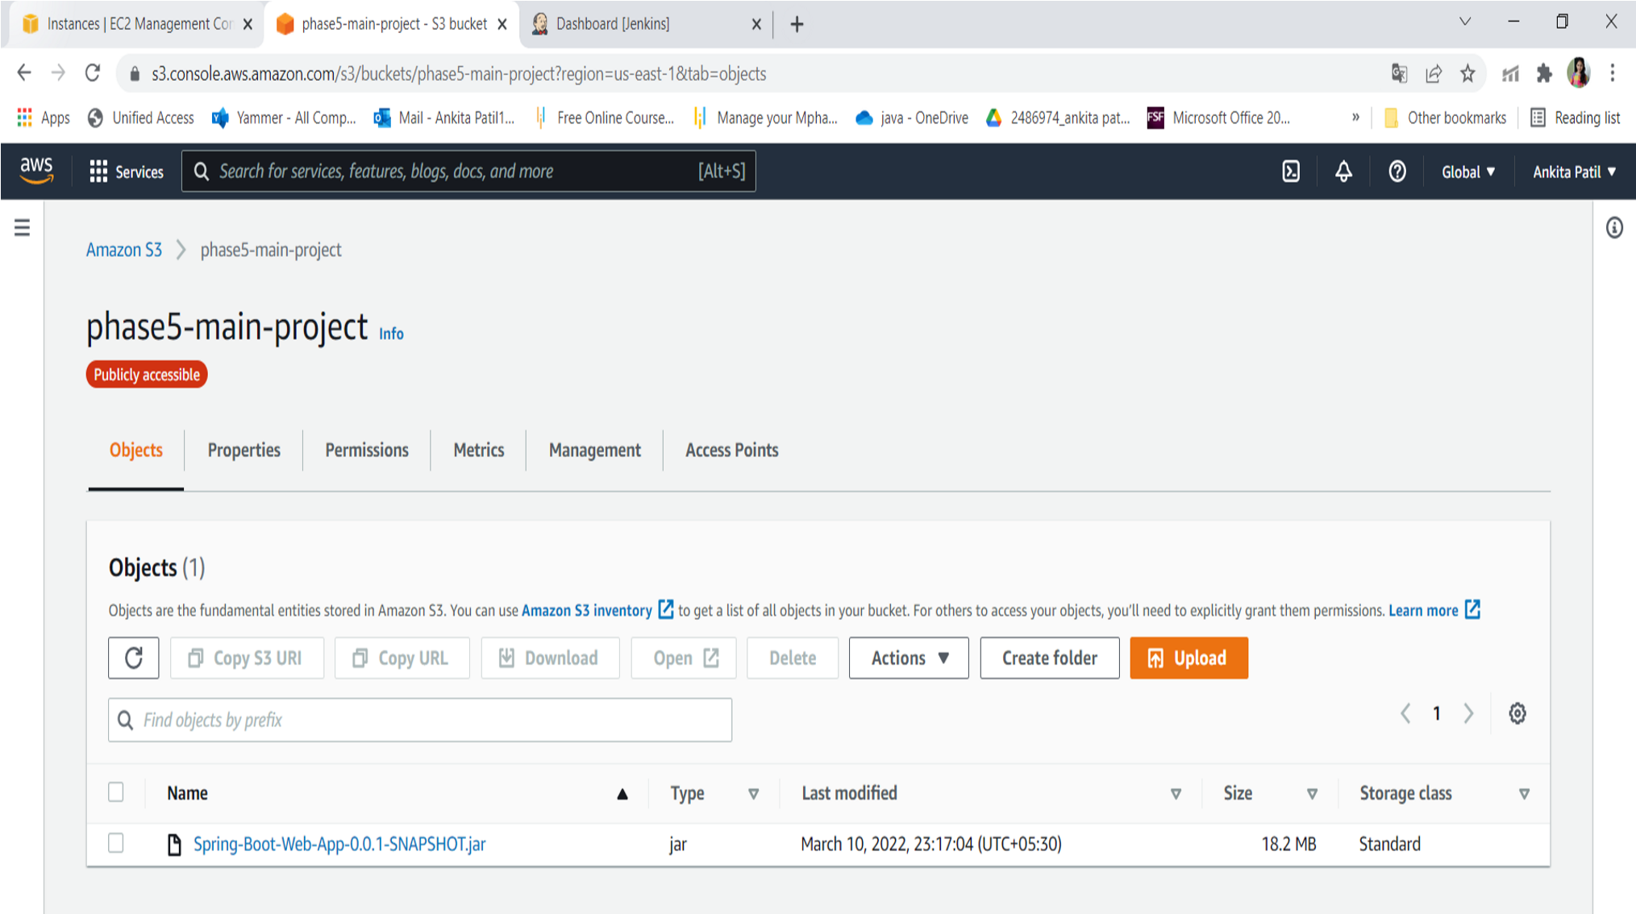

* Run program through instance:

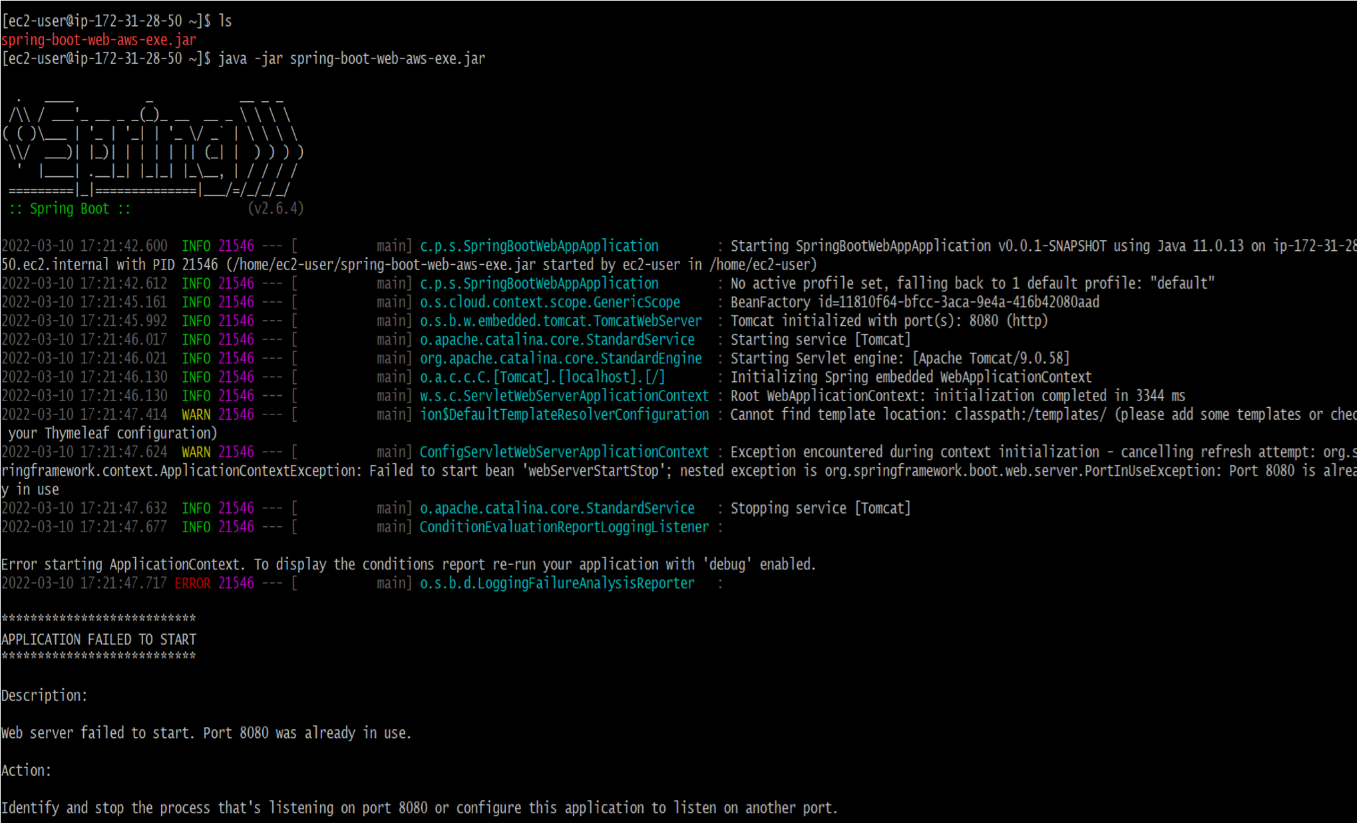

* Output:

